

Kiwanis Junior Italy District

P r o g r a m o f t h e D e m o n s t r a t i o n

f o r t h e

National Training “Zone North”

Division F

Saturday January 24 th 2004

Times 10:00 | Reunion board of directors Kiwanis Junior District of Italy.
Morning | Arrive participants and guests, setup in the hotel “Hotel Lauri” ***, street T. Lauri 6, 62100 Macerata MC, tel. 0733.232376 - www.gestionihotels.it
Times 13:00 | Lunch in center.
Times 15:00 | begin training  Matter of the relationships:  - Opening of the training and regard to the participants;  - What the Kiwanis International is;  - The structure of the Kiwanis International in the world;  - Brief history of the Kiwanis Junior;  - The structure of the Kiwanis Junior in Italy;  - Perspectives of development of the Kiwanis Junior in Italy and in Europe;  Chairmen:  - Riccardo R. G. Cannavò Youth Governor District Italy KJ;  - Marco Rossi Administrator District Italy KJ;  - Giuseppe Spampinato Trainer District Italy KJ;  - Carmelo Carisi National Tutor sponsorized programs Kiwanis;  - Alfonso Cacchiarelli President Kiwanis Club Macerata;
Times 16:30 | Interval.
Times 16:45 | Taken back training  Presidents and Lieutenants;  Chairmen  - Riccardo R. G. Cannavò Youth Governor District Italy KJ;  Secretaries  Chairmen  - Sergio Bellafiore Youth Governor Elect District Italy KJ;  - Anna Lena Secretary District Italy KJ;  Treasurers  Chairmen  - Andrea Denti Treasurer District Italy KJ;  - Massimo Scatà LGT Youth Governor Division B;

Times 18:15 | Interval.
Times 18:45 | debate.  Moderator and manager of the discussion  - Sergio Bellafiore Youth Governor Elect District Italy KJ;
Times 19:45 | Presentation of the web site of the Kiwanis Junior District Italy.  Chairman  - Francesco Albino Webmaster District Italy KJ;
Times 20:15 | End jobs and closing of the training.  Chairmen  - Riccardo R. G. Cannavò Youth Governor District Italy KJ;  - Marco Rossi Administrator District Italy KJ;
Times 21:15 | Typical dinner in the farm "From Dino" in Macerata - Delivery certificates of share.
After dinner | Disco or evening to the pub from to decide on the moment in base to the applications of the participants.

Sunday January 25 th 2004

Times 09:00 | Before Breakfast.
Times 09:30 | Possible prosecution Reunion board of directors Kiwanis Junior District Italy.
Times 11:00 | Visit of the historical center of Macerata.
To the term | Return in hotel and departure participants, in alternative possibility to remain for the lunch;

Costs and formality of adhesion

The demonstration has a cost for person brought in the underlying chart according to the varied available options.

Complete packet: lunch, dinner characteristic, first breakfast, visit of Macerata with night in double room. | € 130
Complete packet: lunch, dinner characteristic, first breakfast, visit of Macerata with night in single room. | € 150
Complete packet: lunch, dinner characteristic, first breakfast, visit of Macerata with night in room triple/quadruple. | € 100

For the one who he/she wanted to stick to the dinner only it is brought following the unitary price:

Rustic dinner in the farm “From Dino.” | € 30

To participate in the demonstration is necessary to compile and to re-send, in the time briefest possible, the forms of adhesion, the price of the amount must be corresponded to the service of reception predisposed by the KJC Macerata. The consignment of the forms can happen anyway, but it is preferred, where possible, the computer compilation and the sent by email. All the compiled forms must have forwarded to the Secretary District Anna Lena. The bookings would have to reach, after of reunion of every club, within on January 15. As notorious the share to the training is anticipated what obligatory from the statute for the Elect President , and Elect Secretary of every club. For the clubs where a Elect Secretary is not be elected the share ill be useful to the training from the incumbent Secretary, so equally a special training is anticipated for Treasurers. And obviously very appreciated the presence and the share from the Presidents of every club. The statute of the District Italy foresees the obligatory share of the besides "Lieutenant Governor Elect" of all the interested Divisions. It goes from oneself that the share of all associates is welcome.
The to regulate share to the training gives title the relative certificate.
Before the official closing of the jobs of the training the presentation of the website of the Kiwanis Junior District Italy will happen (http://www.kiwanisjunior.it /) realized and managed by the Past Youth Governor Francesco Albino, named, with official action, Webmaster of the District from the Board of Directors.
All the clubs that participate will have to bring the banner of the club with them as well as if possible some little flags to effect an exchange with the clubs of the other division consolidating they relationships of friendship, loyalty and respect that they always demonstrating.

How to reach Macerata Distances Macerata - Rome km 287,1
Macerata - Bologna km 279,6
Macerata - Florence km 276
Macerata - Ancona Km 71,4

By airplane: The nearest airport is Ancona “Falconara”, in alternative it is possible to opt for the airports in Rome Fiumicino “Leonardo Da Vinci”, Florence and Forlì.

By train: Macerata it is connected to the principal Italian cities from the national net of the Railroads of the State, FS tel. 892021 - web http://www.trenitalia.com.

By bus: Macerata it is connected to the greatest neighboring cities from different companies of transport, you look for on the web it treats which have interested.

By car: To reach Macerata take the highway A14 Adriatic. Go out to Macerata-Civitanova and to continue in the local fast street up to Macerata.

For any other information, application and inherent necessity the carrying out of the demonstration, the components of the organizational reception office are to complete disposition of the associates.
On the to end of the present the obligation races me to thank all the components of the KJ Macerata that they have well organized the demonstration.

Wait for you !

Kiwanis International
Kiwanis Junior Italy District
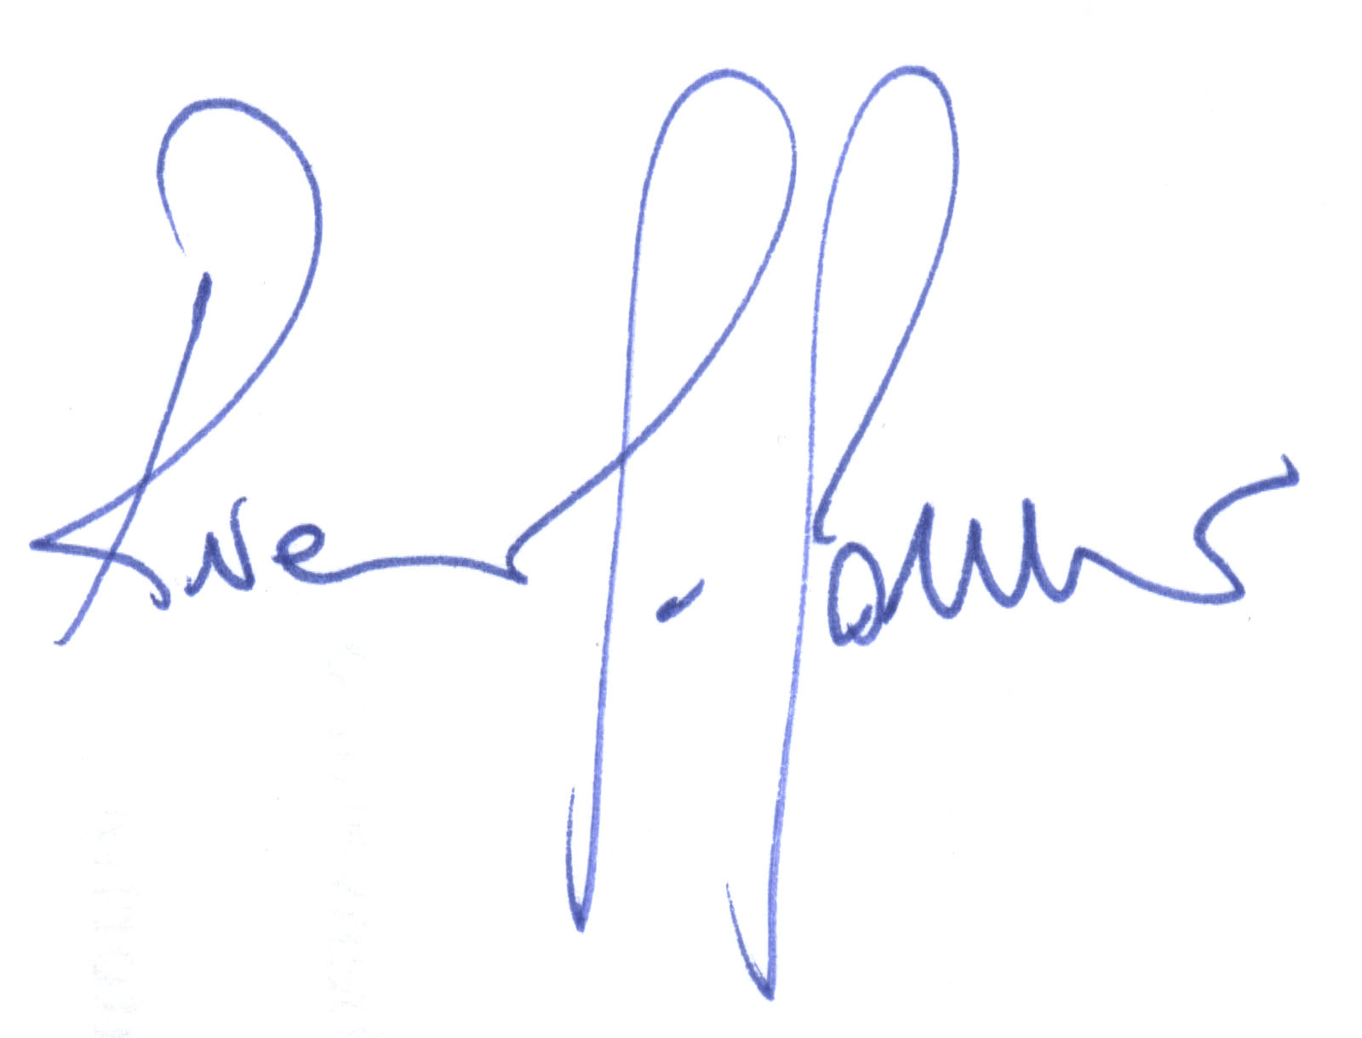
Youth Governor

Riccardo R. G. Cannavò

Organizational reception office of the demonstration

Responsible coordinators

Salvatore Amadio, C/da Chiaravalle 68/C - 62010 Treia MC Valentina Galeotti, Via Roma 350 - 62100 Macerata MC
Tel. 0733.561344 - 338.2110001 - salvomc@libero.it Tel. 0733.33415 - 338.6151433 - galefamily@libero.it

Emanuela Francia, via Martiri delle Foibe 60 - 62012 Civitanova Marche MC
Tel. 0733.530416 - 347.0461779 - lauraemanuela@excite.it

