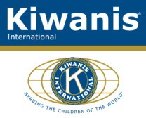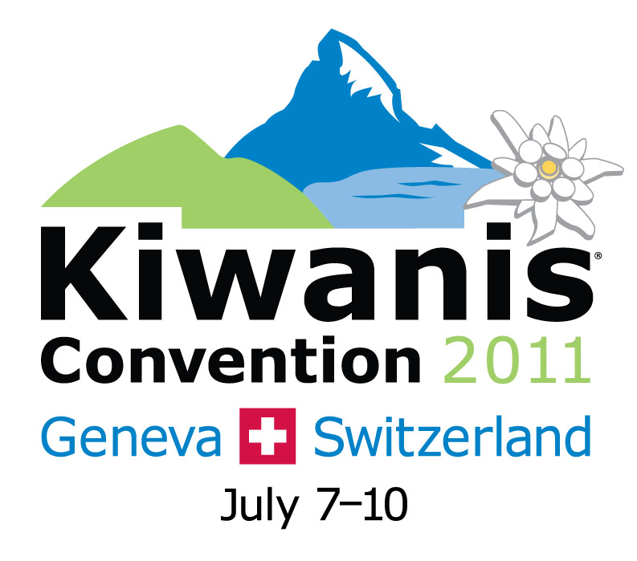

CH- 3612 Steffisburg, 20th Nov 2010

Kiwanis International, Past Trustee

Geneva Kiwanis International Convention Ambassador

Kiwanis International Convention 2011,
07. – 10. July, Geneva (Switzerland)- Issue 3

Dear Kiwanis friend,

KIWANIS INTERNATIONAL – REGISTRATION BY DISTRICT

Based on the last Report (12. NOV 2010), we have 95 members and 31 guests registered for the KI Convention 2011 in Geneva. From Europe, the numbers are: Austria (1), Netherland (2), France-Monaco (4) and Switzerland-Liechtenstein (15). All the others, except 2 Australians, are from the United States or Canada. That’s 22 Europeans to welcome over a hundred Americans and Canadians. I hope the proportion begins to reverse itself, as this convention is on our own continent.

We know that the “Registration Fee” may be a reason why Kiwanians hesitate to fill out the registration form. Kiwanis International explains, in the attached documents, how the convention registration fee is set and what it covers in Geneva. The document is attached in English, French and German.

Your goal as district International Convention chairmen and chairwomen is to promote the convention with your district members and I thank you very much for your commitment earlier this year.

For better planning, we need a short report about the situation in your District and ask you to respond to the followings questions. I ask you to be constructive in your comments, as hard work awaits us all.

- How many member and guests will probably participate in Geneva from your District?
- Does your District plan to offer financial support for the delegates?
- What do you need for a more successful promotion action in your District? (more copies of the videos, Power-Point presentations giving a tour of what an international convention is, ready-written pieces for your magazines in your

language, photos of Geneva, flyers, customized tours in your language through Kuoni, etc.) I remind you that a wealth of information is available on the convention site in English, German and French, please visit often, as new information is posted every week: www.kiwanisone.org/convention, then click on your language at the top. Use the tools provided to help you promote the convention in your district.
- How can we further support you?
- What are your proposals for a successful promotion?

Please give us your answer as soon as possible but no later than the end of November 2010.

How is Kiwanis International currently reaching out directly and regularly to members in Europe about the convention at this time:

All current club leadership and other subscribers receive the KI-Update, an email newsletter published in 8 languages. This newsletter contains stories/information about the convention every month. I strongly encourage you to subscribe to the KI-Update in your choice of language: www.kiwanismagazine.org/subscribe

All current club leadership and other subscribers receive a convention email postcard per month with the latest information related to the convention. You too can subscribe on the convention site, if you haven’t already:

English: http://sites.kiwanis.org/Kiwanis/en/geneva-convention/email.aspx

French: http://sites.kiwanis.org/Kiwanis/fr/geneva-convention/email.aspx

German: http://sites.kiwanis.org/Kiwanis/de/geneva-convention/email.aspx

Important note: The Kiwanis International-European Federation has gracefully accepted to run stories about the convention in the Euroflash and to post convention news on its Facebook page.

A few ideas of good practices you can use on your end:

- Link to the convention site on your district website with at least a short message of explanation.
- Make the convention prominent in any of your district publications, always quoting the website address.
- Include information about the convention in any district mailing, always quoting the website address.
- Use the website information to compose your communications.

Let us know how/if we may help you implement these tasks.

Note: after January 31, 2010, the member convention registration rate goes up by $75 and the guest rate by $50.

I wish you a lot of energy and good ideas to bring a lot of Kiwanians to Geneva.

Theodor Riesen

Past International Trustee
Convention Ambassador
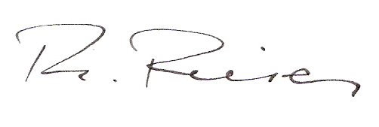

Attached: Information about Convention fee in 3 languages

To: Member of the “Convention Team”
Austria: Axel Begert, Past Governor
Belgium-Luxembourg: Robert Cussano, Governor 2009/2010
France-Monaco: Jean-Germain Wolf, past Governor
Germany: Vacant
Iceland-Feroe: Oskar Gudjonsson, Governor 2009/2010
Italy-San Marino: Alfredo Lisi, Trustee KIF 2003/2006
Netherlands: Sjoerd Timmermans, Past Governor
Norden: Paul Mannes, Governor 2010/2011
Switzerland-Liechtenstein: Marcel Kreienbühl, Past KI-EF President
Poland (DIF): Anna Maldzis,
Czech Rep & Slovakia (DIF): Sona Kapicova

Cc: Jérôme Hennekens, KI-EF President
Paul Inge Paulsen, KI-EF President-Elect
Ernst Van der Weppen, KI-EF Vice-President

Stan Soderstrom, KI Executive Director
Christina Hale, KI Senior Director of Communications, Executive and
partnerships
Fabienne April, KI Global Marketing Strategist
Gunter Gasser, Austria District
Robert Jenefsky, Chairman Host Committee

